
Deep Reinforcement Learning in Atari Games

By

Andre Leonardo Angkawijaya

A Thesis
Submitted to the Faculty of Computing
President Univesity
in Partial Fulfillment of the Requirements
for the Degree of Bachelor of Science
in Information Technology

Cikarang, Bekasi, Indonesia

October 2019
Copyright by

Andre Leonardo Angkawijaya

2019

Deep Reinforcement Learning in Atari Games

By

Andre Leonardo Angkawijaya

Approved:

_________________________________
Dr. Tjong Wan Sen, S. T., M. T.
Thesis Advisor

ABSTRACT

Technologies development grew fast in this era. The flow of information has never become this fast in the human history. Data are precious as it will help the business to win the customer. Data are utilized to analyze the customer needs, enabling the company to know the customer behavior and they could also predict the upcoming trend in their business. Processing the big amount of data, clustering, and analyze them is one of what Artificial Intelligence (AI), a manmade intelligence, can do for human.
AI development does not stop in there. The autonomous self-driving car created by Tesla, the autonomous mechanical hands in the manufacturing companies, the smart Boston Dynamics robots, and a lot of creation was created and inspired by a popular machine learning algorithm, Reinforcement Learning (RL). Studying and implementing this machine learning algorithm should be able to enrich students’ knowledge in AI and help them got the concept of AI in the complex real world problem.
TABLE OF CONTENTS

Page
LIST OF TABLES iv
LIST OF FIGURES v
- INTRODUCTION 6
1.1 Background 6
1.2 Problem Statement 8
1.3 Research Objective 8
1.4 Scope and Limitation 8
1.5 Methodology 9
1.6 Thesis Outline 10
- LITERATURE STUDY 12
2.1 Artificial Intelligence 12
2.2 Machine Learning 12
2.2.1 Supervised and Unsupervised Learning 12
2.2.2 Reinforcement Learning 13
2.2.2.1 Reinforcement Learning Algorithm 13
2.3 Atari Games Environment 14
2.4 Related Works 15
- SYSTEM ANALYSIS 17
3.1 System Overview 17
3.2 Hardware and Software Requirement 17
3.3 Functional Analysis 19
3.4 Use Case Diagram 19
3.5 Use Case Narrative 21
3.6 Activity Diagram 27
- SYSTEM DESIGN 31
4.1 User Interface Design 31
4.2 Physical Design 33
4.3 Data Design 34
4.4 Class Diagram 35
REFERENCES 40

LIST OF TABLES

TABLE Page

Table 1. Use Case Narrative of Train the Agent Node 22
Table 2. Use Case Narrative of Process Data in Deep Q Network Node 23
Table 3. Use Case Narrative of Update the Agent Node 24
Table 4. Use Case Narrative of Pick Environment Node 25
Table 5. Use Case Narrative of Show Results Node 26
Table 6. Software Requirements 33
Table 7. Hardware Requirements 33
Table 8. The Data Design 34

LIST OF FIGURES

FIGURE Page

Figure 1. A non-exhaustive, but useful taxonomy of algorithms in modern RL. Reprinted from Part 2: Kinds of RL Algorithm, in OpenAI Spinning Up, 2018, Retrieved September 12, 2019, from https://spinningup.openai.com/en/latest/spinningup/rl_intro2.html. 14
Figure 2. Gym Retro screenshots collage showing Atari and Sega games environment. Reprinted from Gym Retro, in OpenAI, 2018, Retrieved from https://openai.com/blog/gym-retro/. Copyright 2018 by OpenAI. Reprinted with permission. 15
Figure 3. The algorithm for Deep Q-Learning with experience replay by Mnih et al. (2013) 16
Figure 4. The Functional Analysis Diagram 19
Figure 5. The Use Case Diagram 21
Figure 6. Pick Environment Activity Diagram 27
Figure 7. Initiate Training Activity Diagram 28
Figure 8. Begin Training Activity Diagram 30
Figure 9. The User Interface Design 32
Figure 10. The Application Class Diagram 35
Figure 11. The Network Class' Required Library 41
Figure 12. The Network's Class Init Constructor 42
Figure 13. The build network function 43
Figure 14. The fit function 44
Figure 14. The fit function 44

INTRODUCTION

The introduction consists of the Background, Problem Statement, Research Objectives, Scope and Limitation, Research Methodology and Thesis Outline. The Background explains the current condition of the technology and information accessibility and the main problem that is created by the accessibility. The Problem Statement describes concisely some issues that is solved by the application.

Background
To prosper the quality of human’s life, human began to develop a man-made intelligence, or what we usually called Artificial Intelligence (AI). The long development goal of AI is to achieve the ability for the machine to think and act both rationally and humanly in solving any intellectual human task, which is called Artificial General Intelligence (AGI). In this era, the recent development of AI is in creating an AI that could both think and act rationally.
Google DeepMind and OpenAI are companies that shows AI potential in solving problem that can be trained in simulated environment. RL is utilized by these companies to train an expert agent that outperforms humans in game. The agent created by DeepMind, the AlphaGo Zero, is able to defeat the 18-time world champion Lee Sedol in the game of Go [7]. OpenAI agent is also able to defeat the three best Dota 2 player in

the world in 1v1 match and it puts a tough battle in five bots versus five players mode [5].
By this achievement, the author deducts that using game as the environment to train an agent is the first step in solving complex real-world problem. For example, researcher that would want to create a self-driving car could create an agent which excel in playing racing game. Strategic games also exist in the business such as the strategy to wins marketing, stock exchange, etc.
Seeing the potential of RL, in this study, the author implements Reinforcement Learning (RL) algorithms to create an agent that is excel in playing Atari games. The training results will be an agent that is excel in playing different kinds of Atari games environment.

Problem Statement
AI will become a powerful business tools that could help people to win at business. In order to studies the recent surge of AI trends in business, the author intent to studies and compares different kinds of reinforcement learning algorithm which can train an agent to learn and interact within the specified environment to reach a specified goal.

Research Objective
This study is conducted with the following objectives:
- To implement reinforcement learning as the machine learning algorithm in creating an agent that could outperform human in Atari games.
- To analyse the algorithm performance in the simulated environment to achieve the best result.
- To provide a reference material for students who are interested in this field that would become a base for a more suitable learning process to solve real world problem.

Scope and Limitation
This study was conducted using Q-learning algorithm (and Deep Q Network algorithms) in the Atari games environment. The aspects looked into are the implementation of the algorithm and the agent’s performance in different environments.

Methodology
The author uses the Waterfall Model of software development process. In this model, the whole software development process is divided into four phases where the outcome of one phase will become the input for the next phase. The four phases in this model are:
- Requirement Gathering and analysis − All possible requirements of the system to be developed are captured in this phase and documented in a requirement specification document.
- System Design − the requirement specifications from first phase are studied in this phase and the system design is prepared. This system design helps in specifying hardware and system requirements and helps in defining the overall system architecture.
- Implementation − with inputs from the system design, the system is first developed in small programs called units, which are integrated in the next phase. Each unit is developed and tested for its functionality, which is referred to as Unit Testing.
- Integration and Testing − All the units developed in the implementation phase are integrated into a system after testing of each unit. Post integration the entire system is tested for any faults and failures.

Thesis Outline
The thesis consists of seven chapters, which are:
- Chapter I: Introduction
Introduction consists of Thesis Background, Problem Statement, Research Objective, Scope and Limitation, Methodology, and Thesis Outline.

- Chapter II: Literature Study
Literature Study describes the theoretical basis of references and guidance in the thesis creation.

- Chapter III: System Analysis
System Analysis describes the analysis of the program – its behavior and function. It consists of System Overview, Hardware and Software Requirement, Use Case Diagram, Use Case Narrative, and Activity Diagram.

- Chapter IV: System Design
System Design describes the definition of the program’s architecture, components, and modules. It defines User Interface Design, Physical Design, Data Design, and Class Diagram of the program.

- Chapter V: System Implementation
System Implementation describes how the application is implemented. It consists of User Interface Development and Application Details.

- Chapter VI: System Testing
System Testing contains the testing documentation of the application. Included here are Testing Environment and Testing Scenarios, along with the results.

- Chapter VII: Conclusion and Future Work
This chapter contains conclusion of the research. It also describes possible future improvements in section Future Work.

LITERATURE STUDY

Artificial Intelligence
A man made intelligence. Similar with human, machine receives inputs, calculates, and then show the predictions of the input. carving an intelligence into machine needs an iteration of learning process which is called Machine Learning (ML). In this section, the author describes four popular ML methods which called Supervised, Unsupervised, Semi-supervised, and Reinforcement learning [4].

Machine Learning
Material previously published by the candidate may be included, although if used in the body of the thesis, it must be integrated into the text of the document. Such previously published material must have been originally written as part of the candidate's degree program.

Supervised and Unsupervised Learning
Supervised learning (SL) uses labelled/named data to trains the agents to predicts something, for example, the agent is trained with a labelled fruit images to be able to differentiates fruit’s name when it receives a fruit image. In the Unsupervised Learning (UL), the agents are trained with an unlabelled data to find the pattern and classify the provided data. Market research, social network analysis, and data clustering are the

example of the agents who used this training method. Agents trained using Semi-supervised Learning have the same purposes as SL, however it receives both labelled and unlabelled data.

Reinforcement Learning
RL applies the trial and error learning method, where the agents learn the consequences of their known actions in a specific environment [1]. At the end of their actions, the state of the environment is evaluated. The agents are given a reward according to the environment’s state which can be either positive or negative, the positive reward shown that the agent’s actions satisfy our requirement whereas the negative reward do the opposites.

Reinforcement Learning Algorithm
OpenAI research in RL through various papers line up a nearly accurate taxonomy of algorithms in modern RL as shown by Figure 1 below. The author intend to implement the DQN which stands for Deep Q Network algorithm to train his agent.
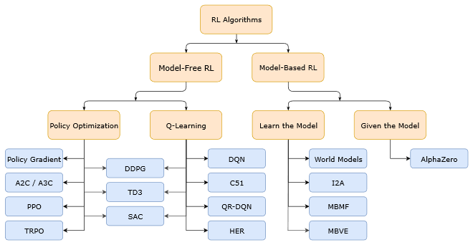
Figure 1. A non-exhaustive, but useful taxonomy of algorithms in modern RL. Reprinted from Part 2: Kinds of RL Algorithm, in OpenAI Spinning Up, 2018, Retrieved September 12, 2019, from https://spinningup.openai.com/en/latest/spinningup/rl_intro2.html.

Atari Games Environment
The uses of games environment as the means to simulated AI learning progress is a popular practice in training AI, especially to trains the AI that will take on a risky task. For example, the intelligence mechanical hand robot which have task on moving heavy or fragile object. If the training were to be conducted in real life, the business will only suffer a lot of damage through the training process. A lot of product or placeholder will be wasted just to train the hand’s capabilities and the hand itself could be damaged through a lot of iterations of learning process.
Thus, game is utilized as it simulates real-life environment which can be used to trains AI to minimalize costs and risks in order to achieve greater task. The author utilizes M. G. Bellemare, Y. Naddaf, J. Veness, & M. Bowling (2013) creation of Arcade Learning Environment (ALE) which is a dedicated simple object-oriented framework for hobbyists and AI researchers to developed AI agents using Atari games as shown by the Figure 2 below. Additionally, the author uses OpenAI Gym, which is an enhanced toolkit for creating an agent trained by RL which uses ALE.
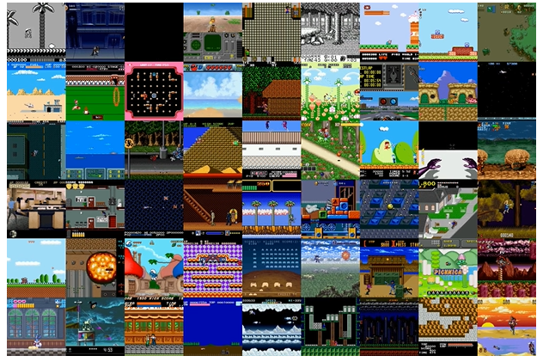
Figure 2. Gym Retro screenshots collage showing Atari and Sega games environment. Reprinted from Gym Retro, in OpenAI, 2018, Retrieved from https://openai.com/blog/gym-retro/. Copyright 2018 by OpenAI. Reprinted with permission.

Related Works
The most popular paper that the author finds throughout his research in this topic is the paper called “Playing Atari with Deep Reinforcement Learning” by Mnih et al. [3] The team introduces the implementation of Q-Learning variant into Deep RL algorithm, which are Deep Q-Network and Deep Q-Network Best, to create a single agent that is capable to achieve the highest score from seven different Atari Games. In their report, Mnih’s team included their reinforcement learning algorithm which is shown in the Figure 3 below.
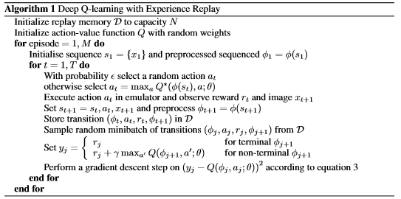
Figure 3. The algorithm for Deep Q-Learning with experience replay by Mnih et al. (2013)

The Deep Q-Learning with experience replay algorithm will be the main algorithm that the author will try to implements and tweaks in his work. Additionally, the other related works that the author found is the bachelor thesis entitled Deep Q-Learning with Feature Exemplified in Atari Pacman by Meo [2]. He experiments between different training setup and algorithm to benchmark and retrieve the most satisfying performance of his algorithm.
Mnih and Meo’s works are the base of the author’s thesis. In his work, the author would like to take a single main algorithm and then compares it with different type of existing reinforcement learning algorithm. Then, the author would tweak different scenario in his setting and record it to search for the satisfying performance that his algorithm implementation can deliver.

SYSTEM ANALYSIS

System Overview
This thesis is intended to implement Deep Q Network Algorithm to train an agent in playing Atari game. The system will train the agent to the point that the agent is able to exploit the environment to achieve the best score as fast as possible. The main objective of the system is to create a system that were able to outperform human in playing games.

Hardware and Software Requirement
Listed below are the software and hardware that are needed to developed this application:
- Personal Computer
A personal computer is where the application resides and be developed, from its earliest stage to its deployment. This application is developed on a PC running 64-bit Windows 10 education.

- JetBrains PyCharm Professional 2019.2.1
PyCharm is a Python Integrated Development Environment (IDE) that can be downloaded for free with a student email. Developed by a Czech company,

JetBrains, PyCharm provides easy code analysis, jupyter notebook supports, an integrated unit tester, integration with version control systems (VCS), and supports web development with Django.

- Microsoft Office
Microsoft Office application, specifically Microsoft Word is used in the making of the application’s documentation.

- Python 3.7.4
Python 3.7.4 is the programming language that is used in the development of the application. Some APIs listed below are used to support the development of the application:
  - Matplotlib
A python 2D plotting library which can produce a variety of plot and histogram which are interactive and cross platform.
  - Tensorflow
Google’s open source machine learning platform that could deliver an easy yet robust machine learning model.
  - Gym
OpenAI’s toolkit for developing and comparing a variety of reinforcement learning algorithm. Using Gym also allows the researchers to create and define their own environment to test their algorithm.

Functional Analysis
The system will be divided into a smaller functional elements which describes the overall system workflow. The system is divided into three sub parts which are preparing the environment, training the agent, and update the agent. The functional analysis diagram could be seen from the Figure 4 below.
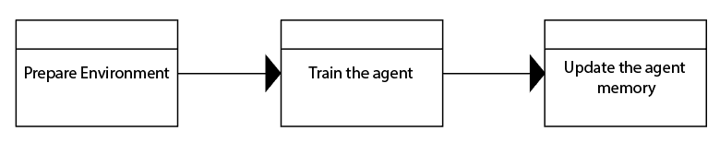
Figure 4. The Functional Analysis Diagram

Use Case Diagram
Use case diagram is a diagram describing dynamic behavior or technical concept of a system. It defines:
- Actors
The internal or external factors interacting with the system depicted by stickman
- Use Cases Nodes
A sequence of actions that provide something of measurable value to an actor depicted by circle.
- Associations Arrow
Dotted arrows which explains a node dependency toward another node.
- Unidirectional Associations Arrow
Arrow which explains a node association toward another figures.
The application’s use case diagram is shown in Figure 5.

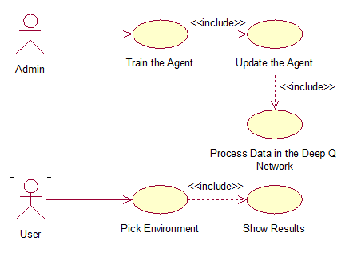
Figure 5. The Use Case Diagram

Use Case Narrative
A detailed textual representation of the sequence of events occurred during the interaction between an actor and the system in use case diagram will be explained in the narratives. The narrative is a table that will explains the prerequisites, conditions, expected results, alternative scenario, exception, goal, and post condition of a use case node. Use case narrative aims is to clarify the system’s behaviors from the early stages.

Table 1. Use Case Narrative of Train the Agent Node
Use Case Name | Train the Agent
Goal in Context | The accuracy of the Agent is increased
Primary Actor | The admin
Secondary Actor | None
Precondition | The environment must exist
Trigger | The admin initializes the environment
Scenario | - The admin initializes the environment  - The admin starts the training process  - The application train the agent to maximize the reward it could get  - The training results are recorded and plotted into a chart
Alternate Scenario | None
Exception | The environment is not exist
Post Condition | The training data are saved

Table 2. Use Case Narrative of Process Data in Deep Q Network Node
Use Case Name | Process Data in Deep Q Network
Goal in Context | The environment data and the agent knowledge are updated
Primary Actor | The admin
Secondary Actor | None
Precondition | The agent is initialized
Trigger | The agent is taking an action that changes the environment
Scenario | - The agent is taking an action that changes the environment  - Both of the environment and agent data are processed into the Convolutional Neural Network  - The agent knowledge base is updated from the retrieved data
Alternate Scenario | None
Exception | None
Post Condition | The agent got the knowledge from the past experience enables it to learn with more accuracy

Table 3. Use Case Narrative of Update the Agent Node
Use Case Name | Update the Agent
Goal in Context | The agent making a progress in every episode
Primary Actor | The admin
Secondary Actor | None
Precondition | The agent is initialized
Trigger | The training to a certain iteration is started by the admin
Scenario | - The training is started by the admin  - The agent is initialized with the default environment information  - The agent takes random action in the environment  - The action updated the environment which puts the agent in a new environment  - The agent stores the knowledges and continue taking random action
Alternate Scenario | None
Exception | If the agent exploits the short-term reward and do not seeks a long-term reward, the agent would not get the best performance.
Post Condition | The agent made a progress in making a decision until it get the best performance or until it reaches the end of the iterations.

Table 4. Use Case Narrative of Pick Environment Node
Use Case Name | Pick Environment
Goal in Context | The environment is initialized
Primary Actor | The user
Secondary Actor | None
Precondition | The application is running
Trigger | The user chooses a specific environment from the combo box
Scenario | - The user chooses an environment  - The environment is initialized
Alternate Scenario | None
Exception | None
Post Condition | The environment is shown to the user

Table 5. Use Case Narrative of Show Results Node
Use Case Name | Show Results
Goal in Context | The training results is shown to the user through a chart
Primary Actor | The user
Secondary Actor | None
Precondition | The user has chosen a specific environment
Trigger | The environment is initialized
Scenario | - The environment is shown to the user  - The results of the agent’s training are shown through a chart
Alternate Scenario | None
Exception | None
Post Condition | The result chart is shown to the user

Activity Diagram
Activity diagrams are graphical representations of workflows of stepwise activities and actions with support for choice, iteration and concurrency. The diagram defines both concurrent and sequential activities which is used by the developers as a lineup of the technical flow of their works. This sub chapter will explain the activities diagram that are used in building this application.
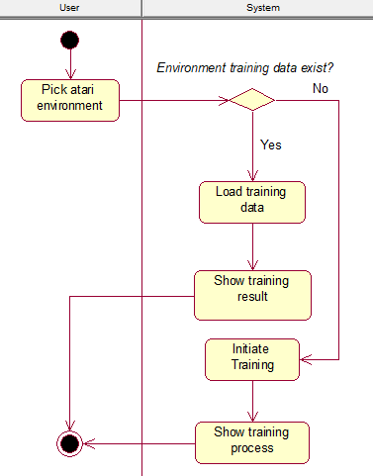
Figure 6. Pick Environment Activity Diagram

The Figure 6 above is derived from the Pick Environment node of the Use Case Diagram. The user who picks the environment will trigger the system to check whether a training data is exist in the environment. If the training already conducted, then the application will simply show the training result to the user. However, in the case where a training is not yet conducted, then the training will be initiated and the process will be visible to the user through the chart generated on the fly when the training is running. The Initiate Training node itself is explained in more detail through the Figure 7 below.
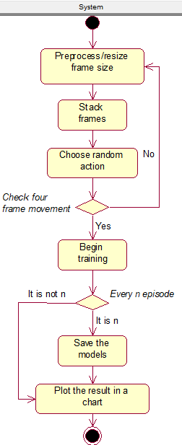
Figure 7. Initiate Training Activity Diagram

The system will be the sole actor of the Initiate Training Activity Diagram. To begin the training, the system will first Preprocess/Resize the environment’s frame to delete meaningless details (extra spaces, scoreboard, etc.). Then, the next process is to Stack Frames so that the system could get the sense of motion. Next, the system will initiate the agent to take a Random Action to update the environment. If the system did not detect an update to the frames in n-steps, it will restart the process all over again from the Preprocess node. Otherwise, the system will Begin the Training Session that will be furtherly explained in the next section that is depicted by Figure 8. The last steps that will end the training session are to Save the trained model for each defined step and Plot the training results into the chart.

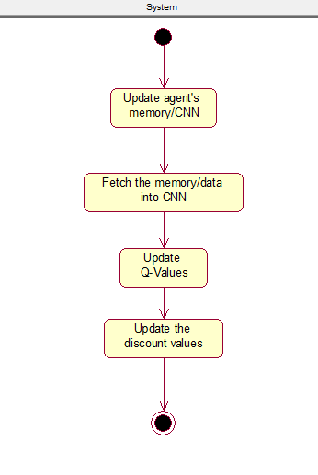
Figure 8. Begin Training Activity Diagram

The Begin Training Activity Diagram which is extended from the Figure 6 is the last activity diagram in this application. The training is started by initializing or updating the agent’s memory. Then, the knowledge that the agent got will be fetched into the Convolutional Neural Network (CNN). After that, the Q-Values will be updated by the new reward function and the Discount Values will also be updated by the CNN.

SYSTEM DESIGN

System Design is the process of defining the architecture, components, modules, and data of a system to satisfy the specified requirements. It can be considered as the intermediate stage between System Analysis and Product Development where the analyses that have been made in the previous chapter are now visualized in detail. The application comprises of four sections: user interface design, physical design, data design, and class diagram.

User Interface Design
User interface design is one of the important components of any application, be it a desktop or a web application. The user interface will allow users to use the application easily. As a desktop application, this application will one interface for the sake of simplicity which is shown by Figure 9 below.

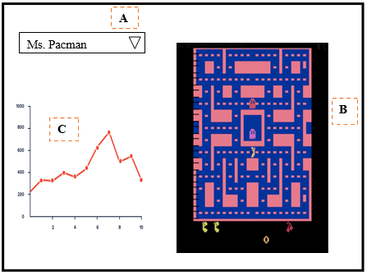
Figure 9. The User Interface Design

Shown by the figure are three main elements, that are represented by A, B, and C, of the User Interface design for this application. The user interface consists of the Atari environment chooser combo box, Atari environment UI, and a line chart which are respectively shown by the orange dotted-line box A, B, and C.

Physical Design
Physical Design defines the minimum requirements of software and hardware used in development process to ensure that the created application runs without problems. The Table 6 and 7 below show respectively the software and hardware requirements to runs this application.
Table 6. Software Requirements
No | Field | Description
1 | Operating System | Windows 10 Education
2 | Programming Language | Python
3 | Program Development | JetBrains PyCharm Professional 2019.2.1
4 | Documentation | Microsoft Word 2019

Table 7. Hardware Requirements
No | Field | Description
1 | Processor | Minimum requirement: Intel Core i series
2 | Memory | Minimum requirement: 2GB of RAM
3 | Monitor | Minimum requirement: Resolution 1280x720
4 | Hard Drive | Minimum requirement: Free space of 100 MB

Data Design
Database is not needed in this application as the application purpose is only to train the agent to be excel in a specific game environment. Therefore, there only exist three data that will be generated to save the checkpoint for the training, evaluation, and taken action in the format of checkpoint (.ckpt) file. Table 8 below depict the data design for the application.
Table 8. The Data Design
No | Filename | Content Description
1 | training_checkpoint.ckpt | The training checkpoint for a defined number of iterations
2 | evaluation_checkpoint.ckpt | The evaluation checkpoint for a defined number of iterations
3 | next_action_checkpoint.ckpt | The next action checkpoint for a defined number of iterations

Class Diagram
A class diagram, as specified in UML, is a static diagram that describes the classes of a system. Classes here are classes in Object Oriented Programming context which displayed with its attributes, methods, and relations with other classes (if exists). Class diagram of this application is shown in Figure 10.

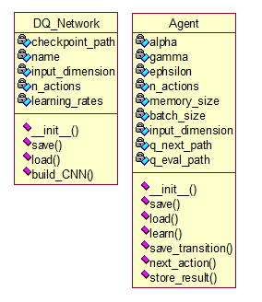
Figure 10. The Application Class Diagram

Two classes, DQ_Network and Agent, are used in this application. As shown by the figure above, no relation exist between classes in the diagrams because all of the classes are used in module. The further explanation of each class will be explained below:
- DQ_Network Class
The DQ_Network Class main purpose is to build a Convolutional Neural Network sfor the agent. There exist five properties to define this class which are:
  - checkpoint_path
The checkpoint_path is used to store the path that will be utilized to either save or load the checkpoint file.
  - name
The name that will be referred from the agent’s name.
  - input_dimension
The input_dimension is used to define the dimension of the input layer for the Convolutional Neural Network.
  - n_actions
The n_actions stands for a number of actions that the agent could take in the specific environment.
  - learning_rates
The learning_rates is a variable which hold a floating-point value from 0 to 1 that defines the learning speed of the agent.

Four methods of the DQ_Network class are explained below:
  - __init__
The __init__ method overwrite the class’s default initializer. It is utilized to initialize the class’s properties along with the TensorFlow session and the build_CNN method.
  - build_CNN
The build_CNN method is the main method of this class. The neural network is configured inside this method.
  - save
The save method is utilized to save the trained models in checkpoint (.ckpt) format.
  - load
The load method is utilized to load the previously trained models in checkpoint (.ckpt) format.
- Agent Class
The Agent Class represent the agent that the neural networks trained. Agent stores the environment and the taken action to feed it to the neural networks to determine the next taken action and also evaluates the previous action. Hence, the agent will be able to create a better decision in taking an action. There exist nine properties that is created for the Agent Class which are:
  - alpha
The alpha variable indicates the learning rate, which is stored in floating-point format, that will be used in the Q-values calculation.
  - batch_size
The batch_size indicates the
  - epsilon
The epsilon value stores a floating-point value between 0 and 1 to determine the agent characteristics to either explore or exploit the taken action.
  - gamma
The gamma value stores a floating-point value between 0 and 1 to determine the importance of the future reward that will be given to the agent.
  - input_dimension
The input_dimension stores the input layer dimension that will be feed to the network.
  - memory_size
The memory_size stores the memory size that the agent could hold.
  - n_actions
The n_actions stands for a number of actions that the agent could take in the specific environment.
  - q_eval_path
The q_eval_path stores the path string to save the checkpoint for the evaluation.
  - q_next_path
The q_next_path stores the path string to save the checkpoint for the next taken action training.

Seven methods in the Agent Class are explained below:
  - __init__
The __init__ method overwrite the class’s default initializer. It is utilized to initialize the class’s properties.
  - save
The save method is utilized to save the trained models in checkpoint (.ckpt) format.
  - load
The load method is utilized to load the previously trained models in checkpoint (.ckpt) format.
  - learn
The learn method is the main method where the CNN will be run and the Q-values will be updated.
  - save_transition
The save_transition method is utilized to save the taken action and the environment states to the agent’ memory.
  - next_action
The next_action method is used to determine whether the agent should explore or exploit the environment.
  - store_result
The store_result method is used to store the training result and plot itinto the chart.

SYSTEM IMPLEMENTATION

This chapter describes the process of implementing the algorithm of Deep Q Network with Experience Replay in Atari games using Python 3. The algorithm was implemented by the creation of Network, Agent, and Main class. The Network and Agent classes are the supporting classes that will build the Deep Q Network algorithm in the Main class. The Network class defines the neural network model that the Agent will be using in training. The Agent class was used to defines the , memory, and decision-making mechanism. In the last class, the Main class, was used to define and run the main Deep Q Learning algorithm.

The Network Class
The component to build the agent’s neural network model is defined in the Network class. As mentioned before in the previous chapter, the agent utilizes a Convolutional Neural Network to recognize the feature inside the Atari game’s frame. The Network class takes the action and input of the environment then feeds it into the CNN. The model will learn the input and try to predict the action by updating the q values list.

The Constructor
The following library shown by Figure 11 are utilized in creating the Network class.
import os
import numpy as np
from keras.optimizers import RMSprop
from keras.models import Sequential, Model
from keras.layers import Dense, Conv2D, Flatten
from keras.initializers import VarianceScaling
Figure 11. The Network Class' Required Library

As shown by the figure above, the Network class import the layers, optimizers, initializers, and models from Keras library for the need of building a Convolutional Neural Network model. Numpy is a library that will be used for creating array and os is a library that will be utilized for file management. The class’ constructor will be explained in the next paragraph according to the Figure 12 below.
Figure 12. The Network's Class Init Constructor
class DeepQNetwork(object):
def __init__(self, total_action, learning_rate,
fcl_dims=512, input_dimension=(210, 160, 4)):
self.total_action = total_action
self.learning_rate = learning_rate
self.fcl_dims = fcl_dims
self.input_dimension = input_dimension

# Init DQN
self.model = self.build_network()
self.q_target_model = self.build_network()
plot_model(model, to_file='model.png')

The class accept total_action and learning_rate as parameters without default value. These two parameters were created without default value as it will ease the author in testing different games which have various number of actions with different speed. The other two parameters which are fcl_dims and input_dimension with respectively 512 and (210, 160, 4) as the default values.
The model and q_target_model are the variables that contain the current and the target q_values. These variables are initialized by the function build_network that will be explained in the next section.

The Build Network Function
The build network function is defined through the Figure 13 below.
Figure 13. The build network function
def build_network(self):
# CNN
model = Sequential()
model.add(Conv2D(32, kernel_size=8, strides=4, activation='relu', input_shape=self.input_dimension,
kernel_initializer=VarianceScaling(scale=2.0)))
model.add(Conv2D(64, kernel_size=4, strides=2, activation='relu',
kernel_initializer=VarianceScaling(scale=2.0)))
model.add(Conv2D(64, kernel_size=3, activation='relu'))

model.add(Flatten())
model.add(Dense(self.fcl_dims, activation='relu',
kernel_initializer=VarianceScaling(scale=2.0)))
model.add(Dense(units=self.total_action, kernel_initializer=VarianceScaling(scale=2.0)))
model.compile(RMSprop(learning_rate), 'mean_squared_error')

return model

The CNN built using three convolutional layers, one flatten layer, and a fully connected layers with 512 nodes. In the end, the convolutional layers are compiled using a RMSProp activation function and mean_squared_error loss function. Both activation and loss function are the best function chosen according to DeepMind research.

The Fit Function
A fit function is a Keras’ function in order to train the neural network model. In the Figure 14 below, the author defines the fit function into the Network class. The author set the epochs to one, as the training loop will be conducted by the game’ episode loop that will be defined in the Main class.
def fit(self, state, q_values):
self.model.fit(input, state, q_values, epochs=1, verbose=2)
Figure 14. The fit function

The Predict Functions
The predict functions works by utilizing Keras’ function to predict the result according to the neural network’ input. Figure 15 below shows the predict function for both the current and the target q_value prediction.
def predict(self, state):
return self.model.predict(state)

def predict_target(self, state):
return self.q_target_model.predict(state)
Figure 15. The predict functions for the two q values

The Save and Load Functions
The save and load functions works to save and load the model’ weight both functions are available in Keras. These functions are shown through the Figure 16 below.
def save(self, path):
self.model.save_weights(path + '.h5')

def load_weights(self, path):
self.model.load_weights(path)
Figure 16. The save and load weight functions

The Agent Class
The agent will accept the hyperparameters of the Q functions which will be used to predict the future rewards in accordance to the current state and action taken. The way to choose an action will be explains through the usage of the epsilon. The agent also has a memory mechanism that will stores and sample the history of the episode.

The Constructor
Learning rate, discount factor, epsilon, epsilon decay, total action, and input dimensions are the q function hyperparameters that are initialized in the constructor of this class as shown by the Figure 17.
# Hyper parameters
self.learning_rate = learning_rate
self.discount_factor = discount_factor
self.epsilon = epsilon
self.epsilon_decay = 0.99
self.total_action = total_action
self.input_dims = input_dims
Figure 17. The agent' hyperparameters

The agent’s memory is created by python’ deque function from the collection library. The agent has a batch size and memory counter to support the random sampling of mini batches of memory as shown by Figure 18.
# Initialize memory
self.batch_size = batch_size
self.memory = deque()
self.memory_counter = 0
self.memory_size = memory_size
Figure 18. The agent's memory

The last properties that needs to be initialized was the agent’s neural network. This will be done by instantiating a Network class into a variable called model as shown by the Figure 19 below.
# Initialize network model
self.network = DeepQNetwork(self.total_action, self.learning_rate)
Figure 19. The agent's network
The full code of the Agent class constructor is shown through the Figure 20 below.
class Agent(object):
def __init__(self, learning_rate, discount_factor, epsilon, total_action, batch_size,
memory_size=20000, input_dims=(210, 160, 4)):
# Hyper parameters
self.learning_rate = learning_rate
self.discount_factor = discount_factor
self.epsilon = epsilon
self.epsilon_decay = 0.99
self.total_action = total_action
self.input_dims = input_dims

# Initialize memory
self.batch_size = batch_size
self.memory = deque()
self.memory_counter = 0
self.memory_size = memory_size

# Initialize network model
self.network = DeepQNetwork(self.total_action, self.learning_rate)
Figure 20. The agent' constructor

Storing Memory Function
An episode is a set of state, action, reward, done variable, and next state. As the memory already initialized in the constructor, the function will append the inputted episode into the memory and increase the memory counter. If the memory exceed the limit, the least stored memory will be erased from the memory to give a space for the newest memory as shown by Figure 21.
# Storing memory
def store_transition(self, state, action, reward, done, next_state):
exp = (state, action, reward, done, next_state)
if self.memory_counter < self.memory_size:
self.memory_counter += 1
else:
self.memory.popleft()
self.memory.append(exp)
Figure 21. The agent' memory storage function

Choosing Action Function
A policy to choose an action is defined through the choose_action function. The randomness of our agent decision making is handle through the random function provided by the numpy library. In the conditional code below in Figure 22, it is shown that the agent will choose either to explore or exploit depending on the randomness value compared to the defined epsilon value. The breakdown of the full policy function is defined in the next paragraph.
# Policy
def choose_action(self, state):
random = np.random.random()
if random <= self.epsilon:
action = np.random.choice(self.action_space)
else:
actions = self.q_eval.run(self.q_eval.q_values, feed_dict={self.q_eval.input: state})
action = np.argmax(actions)
return action
Figure 22. The policy function
An exploration is indicated by the agent taking a random action from the defined action space whenever the random value is less or equal then the epsilon value. The act of the agent exploring the action space is shown through the Figure 23.
if random <= self.epsilon:
action = np.random.choice(self.action_space)
Figure 23. The exploration code

On the other hand, an exploitation is defined by a q value evaluation network to update the list of q values, then the agent will choose the highest q values which indicated an action that will lead into most favorable reward as shown by Figure 24.
else:
actions = self.q_eval.run(self.q_eval.q_values, feed_dict={self.q_eval.input: state})
action = np.argmax(actions)
Figure 24. The exploitation code

Sampling Function
The function to sample a random batch of episode from the memory is started by comparing the memory counter and the memory size. Numpy function then utilized to randomly choice an action in the range of the memory counter and the maximum memory as shown by the Figure 25.
Figure 25. Randomly choosing an episode from the memory
max_memory = self.memory_counter if self.memory_counter < self.memory_size else self.memory_size

batch = np.random.choice(self.memory, max_memory)
After a batch of episode have been fetch from the memory, the episode content will be fetch into the new container of state, action, done, and next state. Then, it will be returned to the new container as shown by Figure 26. The Figure 27 below Figure 26 is the full code of the sampling function.
state_batch = np.array([i[0] for i in batch])
action_batch = np.array([i[1] for i in batch])
reward_batch = np.array([i[2] for i in batch])
done_batch = np.array([i[3] for i in batch])
next_state_batch = np.array([i[4] for i in batch])

return state_batch, action_batch, reward_batch, done_batch, next_state_batch
Figure 26. Episode batch storing
# Sampling
def sample_exp_batch(self, batch_size):
max_memory = self.memory_counter if self.memory_counter < self.memory_size else self.memory_size

batch = np.random.choice(self.memory, max_memory)

state_batch = np.array([i[0] for i in batch])
action_batch = np.array([i[1] for i in batch])
reward_batch = np.array([i[2] for i in batch])
terminal_state_batch = np.array([i[3] for i in batch])
next_state_batch = np.array([i[4] for i in batch])

return state_batch, action_batch, reward_batch, terminal_state_batch, next_state_batch
Figure 27. The sampling function

The Learning Function
The learning function created based on the experience replay. The agent learn to predict the q values based on the game stored history that were fetched by utilizing the sampling function. For each state stored in the state space of the sample, the agent will try to maximize the action taken to get the highest reward. However if the agent read the end state, the agent will only take the current reward to the q list. The q list then will be fetch into the neural network then the training begin. In the end of the function, the epsilon, which is used by the choosing action function, will be decayed if a certain epsilon threshold is reached.
# Learning with Experience Replay
def learn(self):
state, action, reward, done, next_state = self.sample_exp_batch(self.memory_size)

q = self.network.predict(state)
q_next = self.network.predict(next_state)
q_target = self.network.predict_target(state)

for i in range(state.shape[0]):
if done[i]:
q[i, action[i]] = reward[i]
else:
next_best_action = np.argmax(q_next[i, :])
q[i, action[i]] = reward[i] + self.discount_factor * q_target[i, next_best_action]
self.network.fit(state, q)

if self.memory_counter > 10000:
if self.epsilon > 0.05:
self.epsilon *= self.epsilon_decay
else:
self.epsilon = 0.05

Figure 28. The learning function

The Save and Load Functions
The save and load functions works to save and load the model’ weight both functions are available in Keras. These functions are shown through the Figure 29 below.
Figure 29. The save and load weight functions
def save_weights(self, path):
self.network.save(path)

def load_weights(self, path):
self.network.load_weights(path)

The Main Class
The Main class is utilized to preprocess Atari games frame and to lay out the DQN algorithm implementation.

The Constant
Seven constants which are the hyper parameters of the agent is defined in the beginning of the code as shown by Figure 30 below.
ALPHA = 0.00025
EPSILON = 0.5
GAMMA = 0.99
INPUT_DIMS = (180, 160, 4)
TOTAL_ACTION = 3
MEMORY_SIZE = 50000
BATCH_SIZE = 32
Figure 30. The hyper parameters as constants

Data Preprocessing
The Atari games frames is a high dimensional data which have a lot of information stored in the form of pixels. To minimize the computation, the Atari game’ frame is converted from RGB color scheme into grayscale color scheme. The dimensionality is also reduced from 210x164 into 84x84.
Furthermore, to create a sense of movement/velocity, the game’ frame will be stacked into four consecutive frame. The stacking procedure was achieved by creating an array using numpy library. The past three frame that already occurred in the game was put into the first three address in the array while the current frame will be stacked into the fourth address. The process of preprocessing the frame of the games and stacking four consecutive frames is shown respectively by the preprocess and stack_frames functions shown by Figure 31 below.
def preprocess(observation):
observation = observation / 255
return np.mean(observation[30:, :], axis=2).reshape(180, 60, 1)

def stack_frames(stacked_frames, frame, buffer_size):
if stacked_frames is None:
stacked_frames = np.zeros((buffer_size, *frame.shape))
for i, j in enumerate(stacked_frames):
stacked_frames[i, :] = frame
else:
stacked_frames[0:buffer_size - 1, :] = stacked_frames[1:, :]
stacked_frames[buffer_size - 1, :] = frame

stacked_frames = stacked_frames.reshape(1, *frame.shape[0:2], buffer_size)
return stacked_frames
Figure 31. The preprocess and frame stacking functions

The Main Function

SYSTEM testing

System Design is the process of defining the architecture, components, modules, and data of a system to satisfy the specified requirements. It can be considered as the intermediate stage between System Analysis and Product Development where the analyses that have been made in the previous chapter are now visualized in detail. The application comprises of four sections: user interface design, physical design, data design, and class diagram.

conclusion and future work

System Design is the process of defining the architecture, components, modules, and data of a system to satisfy the specified requirements. It can be considered as the intermediate stage between System Analysis and Product Development where the analyses that have been made in the previous chapter are now visualized in detail. The application comprises of four sections: user interface design, physical design, data design, and class diagram.

REFERENCES

[1] Andrew, N. G. (n.d.). Part XIII Reinforcement Learning and Control [PDF document]. Retrieved from CS229 Stanford Edu Website: http://cs229.stanford.edu/notes/cs229-notes12.pdf
[2] Meo, R. (n. d.). Deep Q-Learning with Feature Exemplified by Pacman (Bachelor’s Thesis, Hamburg University of Applied Sciences). Retrieved from http://edoc.sub.uni-hamburg.de/haw/volltexte/2018/4168/pdf/Roland_Meo_BA_Thesis.pdf
[3] Mnih et al. (2013, December 19). Playing Atari with Deep Reinforcement Learning [PDF]. Retrieved from https://www.cs.toronto.edu/~vmnih/docs/dqn.pdf
[4] Musumeci et al. (2018). An Overview on Application of Machine Learning Techniques in Optical Networks [PDF document]. Retrieved from https://arxiv.org/pdf/1803.07976.pdf
[5] OpenAI Five. (n.d.). Retrieved from https://openai.com/five/
[6] Pfau et al. (2018). Gym Retro screenshots collage showing Atari and Sega games environment. [Screenshots collage]. Retrieved from https://openai.com/blog/gym-retro/
[7] The Google DeepMind Challenge Match. (n.d.). Retrieved from https://deepmind.com/alphago-korea

